ZoomGov User’s Guide for Ivy
Linux VMs
Screen sharing through ZoomGov will enable you to share the screen of your Ivy environment securely. For Linux VMs, follow the steps below to share your desktop session.
- Log into the High Security VPN and open the internet browser of your choice.
- In the address bar, type “https://” followed by the IP address of your Linux VM (e.g. https://10.xxx.xx.xxx). Note: your VM’s IP address is provided in the Ivy Services app.
- Once connected, launch the FastX Desktop server.
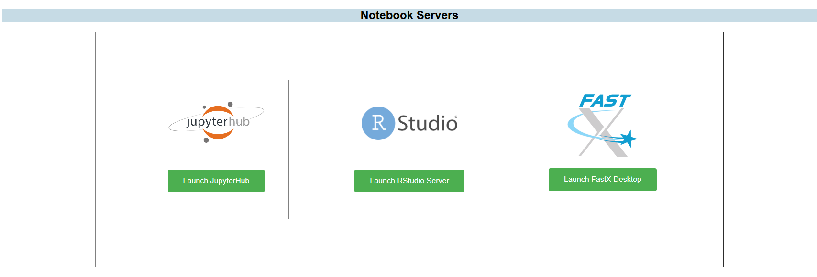
- Within FastX, launch the MATE application to create a virtual desktop session to share from by selecting the green MATE icon under the Applications panel, and then launching the MATE session.
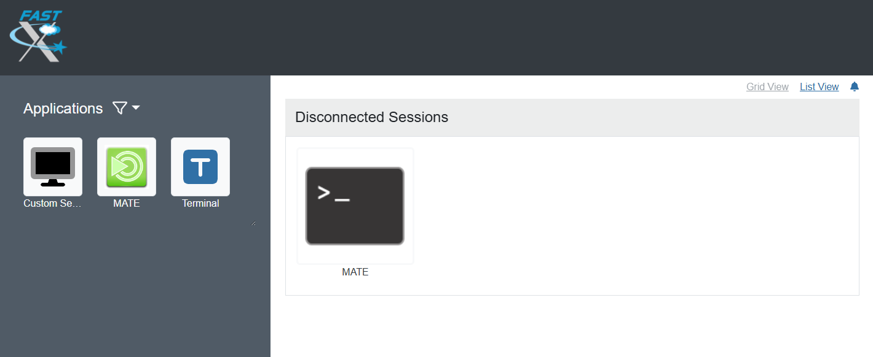
- Sessions can be connected from the Browser Client or the Desktop Client. For this document, the Browser Client will be used.
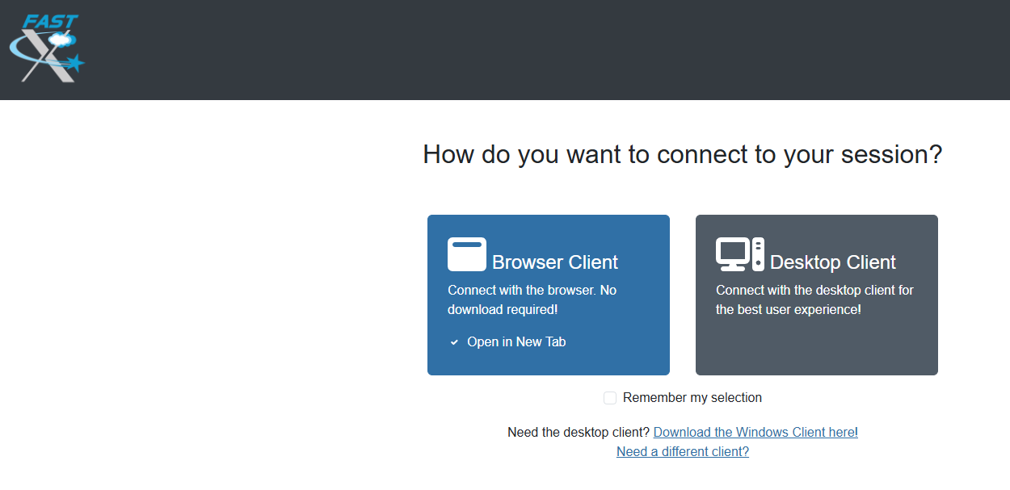
- Once the browser client is loaded, navigate to the high-security research standard storage folder from the File System icon.
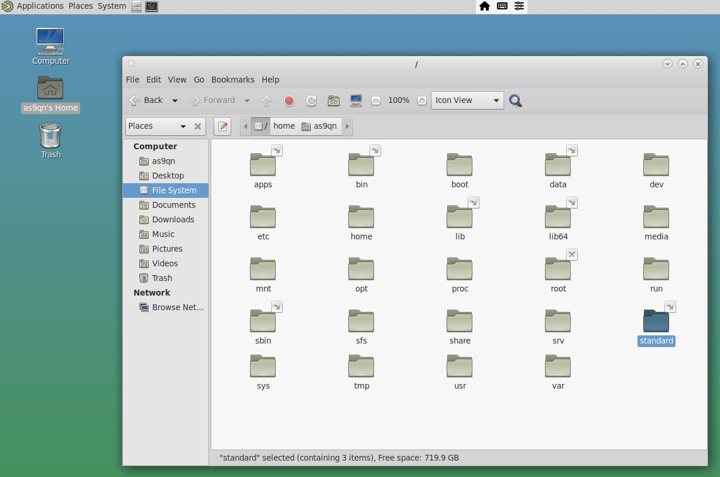
- Load the document(s) you wish to present through ZoomGov.
- Start the ZoomGov application to start your meeting.
- Navigate to the green Share icon and select the window you wish to share.
